**Roper Pump Introduces Smaller Sizes for eX Series Pumps**

**Now available in sizes 11, 17, and 22**

**October 24, 2024 –** Roper Pump Company, a leader in innovative pumping solutions, is excited to announce the expansion of its eX Series with smaller sizes. Sizes 11, 17, and 22 will maintain existing, compact footprints while offering superior performance when handling a wide range of viscosities from condensate to heavy crude.

With enhanced materials, the eX Series delivers increased output and durability, setting a new industry standard for flow rates and adaptability.

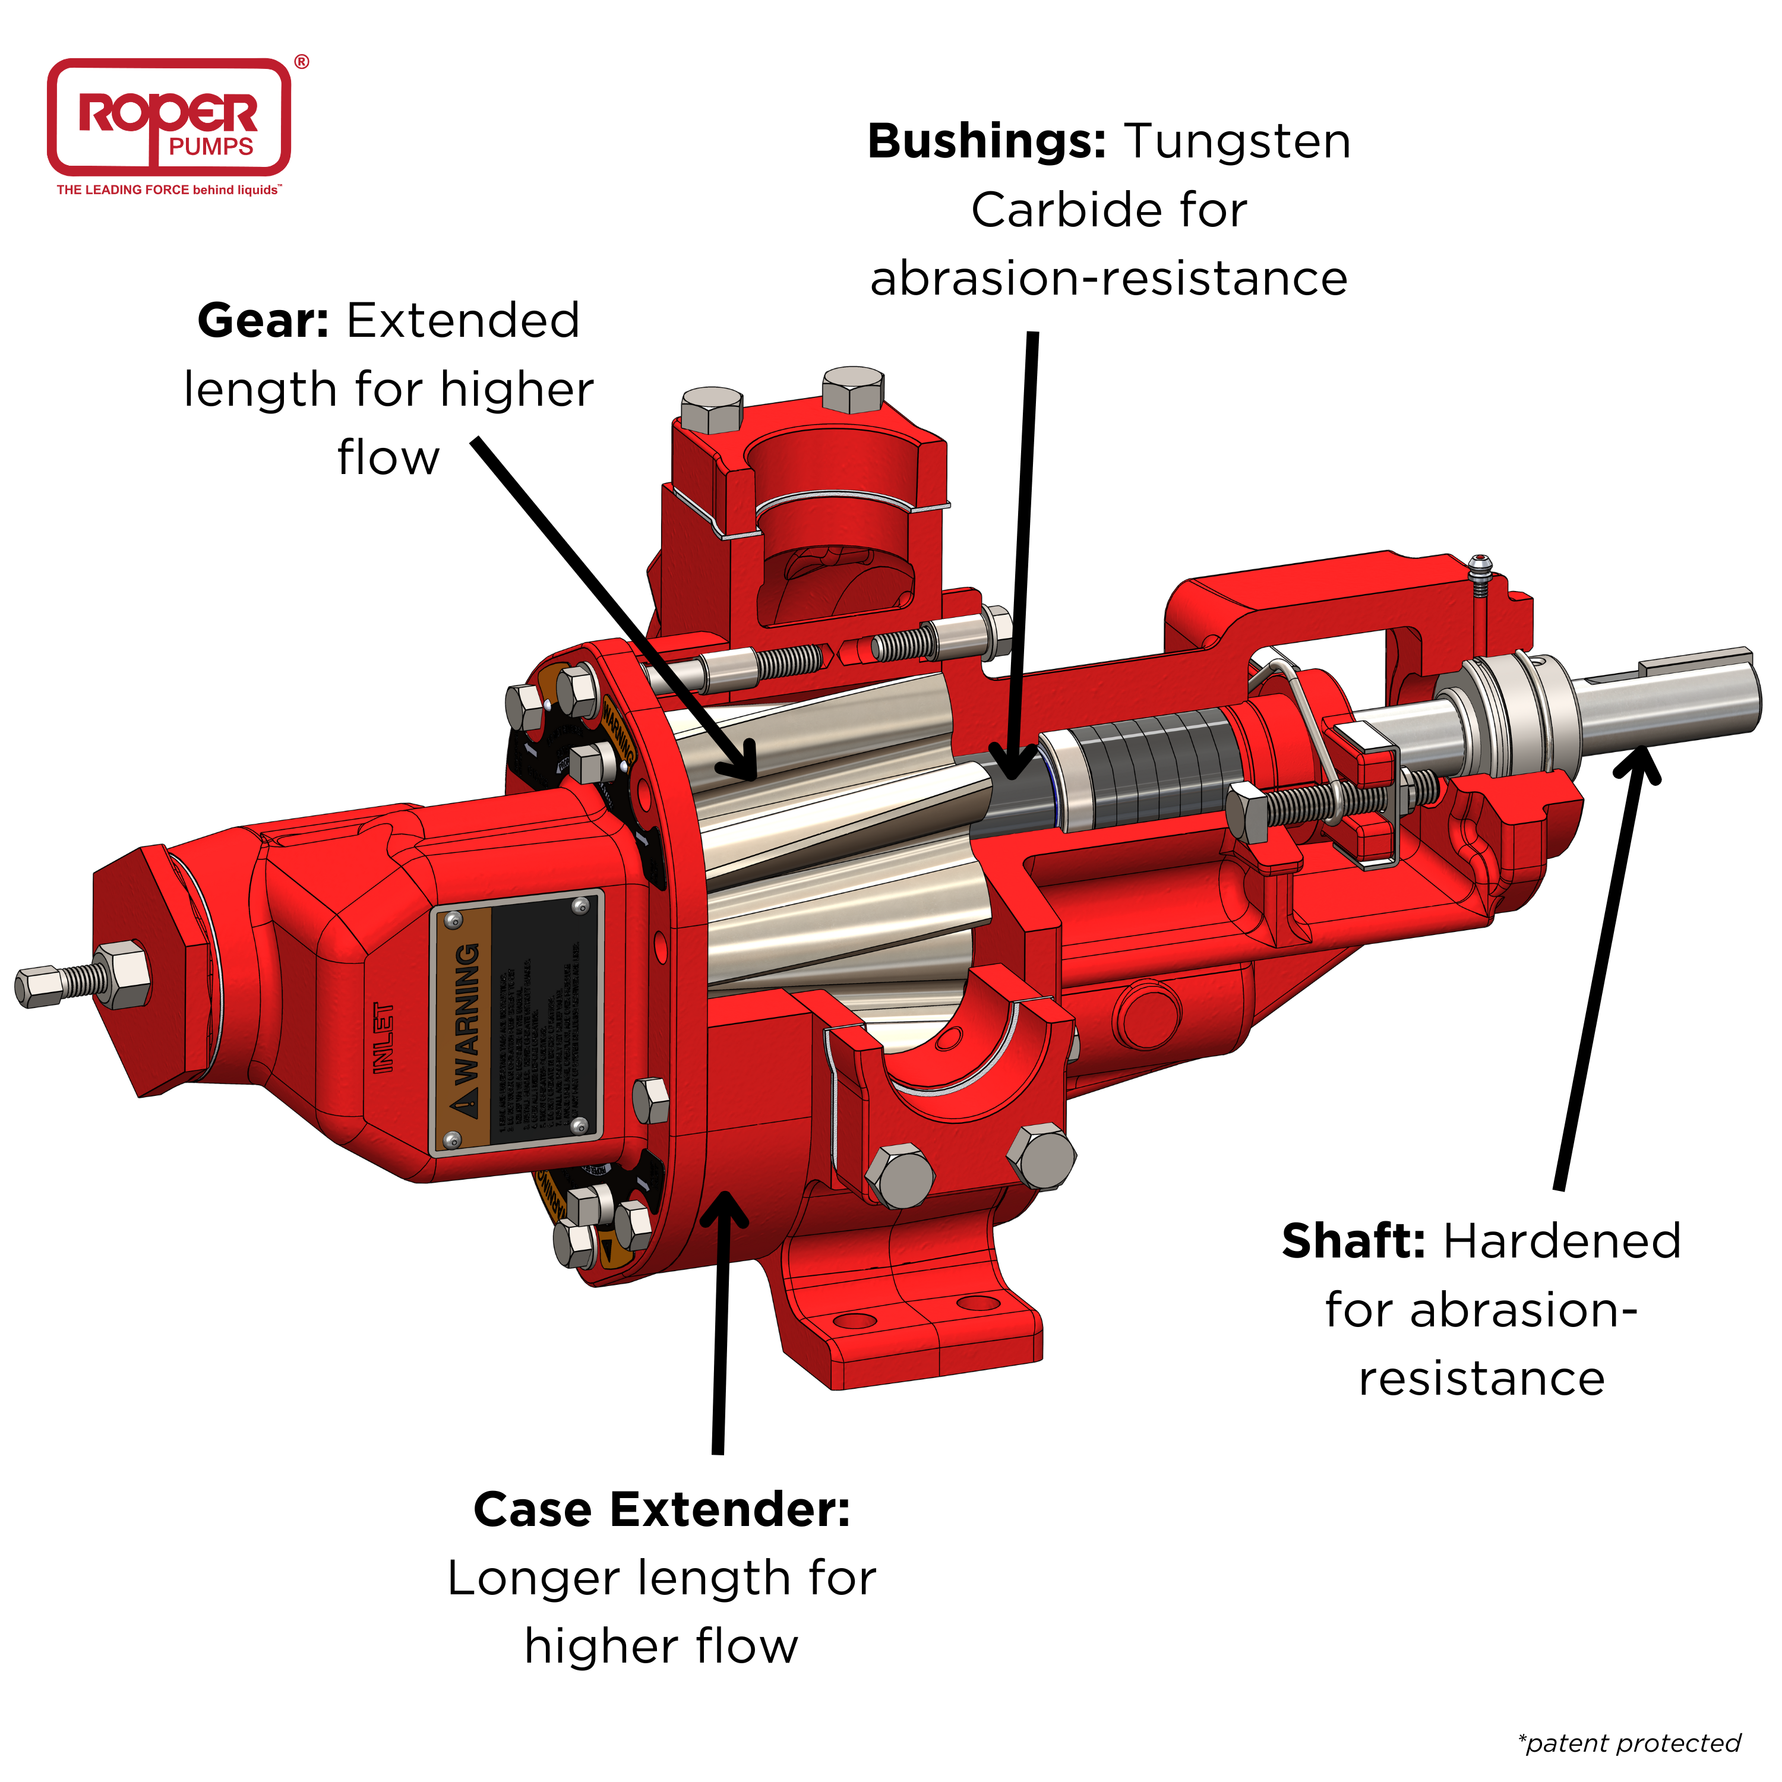

Dan Johnston, V.P. of Sales and Marketing, stated, “The eX Series pump reflects our commitment to innovation, offering customers a reliable, high-performance solution that exceeds expectations.”

Roper Pump’s eX Series is set to revolutionize fluid handling across various industries setting a new gold standard for performance, durability, and versatility. Industries include, but are not limited to, railcar and marine terminal, industrial fluids, oils, resins, bulk transfer, and more. For more information about the eX Series pump and other solutions from Roper Pump Company, visit [roperpumps.com](https://roperpumps.com/eX-Series/).

**About Roper Pump Company**

Roper Pump Company is a leading provider of innovative pumping solutions. With over 165 years of experience, Roper Pump has established itself as a trusted partner to industries around the world, including transportation, oil and gas, chemical, brewing, and other industrial markets. For more information, visit our website at [roperpumps.com](https://roperpumps.com/3632-high-flow-3/).