1. *New product announcement*  
     
   Roper Pump introduces smaller sizes for eX Series pump!

The eX Series is here and now available in sizes 11, 17, & 22. Features include:  
-Hardened internals for superior durability  
-Higher flow rates in existing footprint  
-Improved sealing options to eliminate leaking  
-No external grease system required  
-Easy to maintain  
  
Call today and discover the all-new eX series.  
📱(706) 335-5551  
<https://roperpumps.com/eX-Series/>#innovation #pumpingsolutions #georgiapumpingsolutions #industry #pumpingsolutions #RoperPumpCompany #efficiency #industrialsolutions

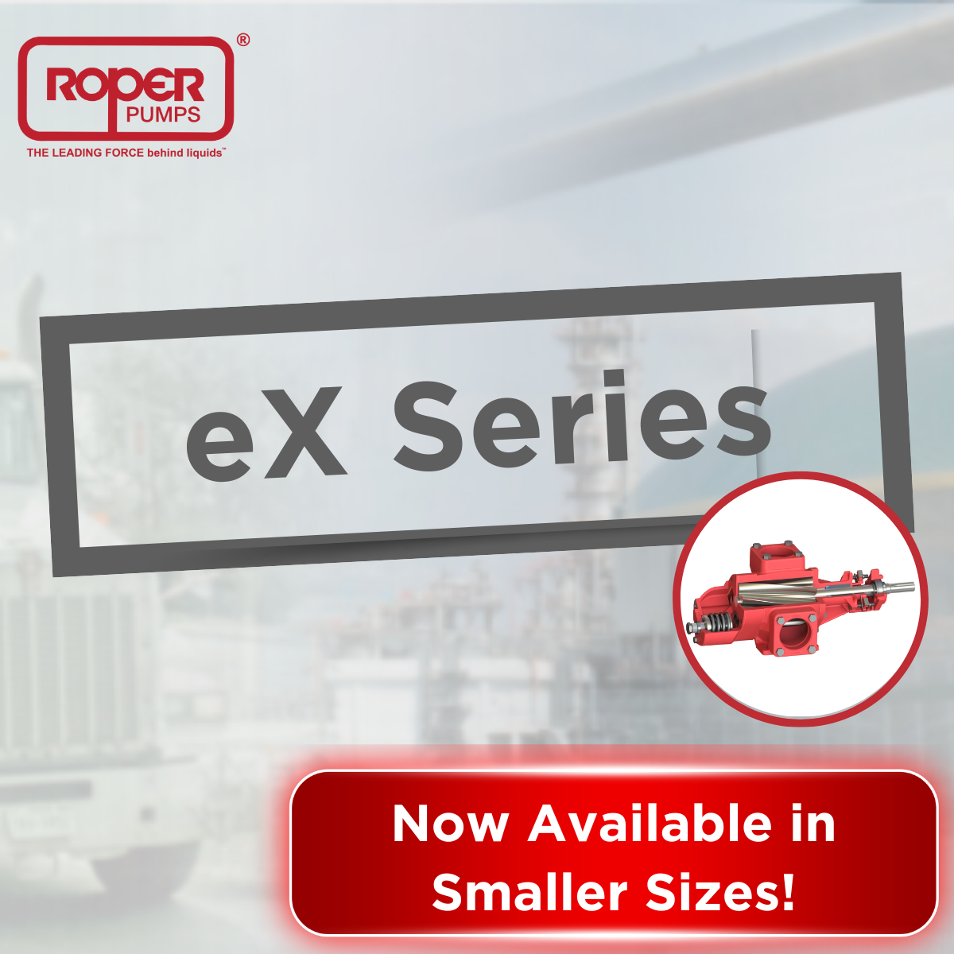

1. Need to handle abrasive fluids while maintaining your existing footprint?

We’re proud to announce the eX Series pump has set a new standard in the industry, and it’s now available in smaller sizes. With it’s hardened internals, this pump provides superior dependability, extended pump life, an unprecedented adaptability to handling multiple viscosities, and produces industry-leading flow rates.

Call today and discover the eX series.  
📱(706) 335-5551  
<https://roperpumps.com/eX-Series/>#innovation #pumpingsolutions #georgiapumpingsolutions #industry #pumpingsolutions #RoperPumpCompany #efficiency

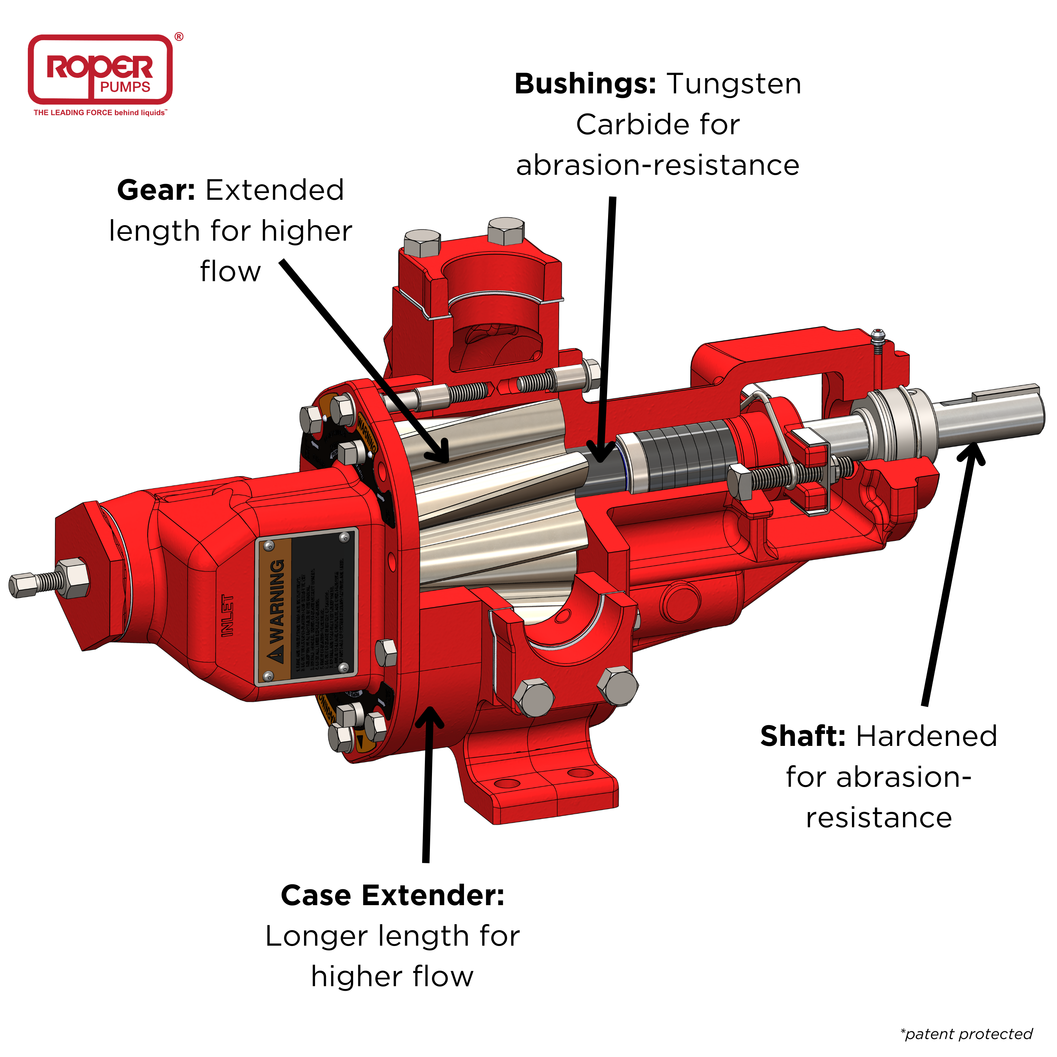

Call today and discover the all-new eX series.  
📱(706) 335-5551  
<https://roperpumps.com/eX-Series/>#innovation #pumpingsolutions #georgiapumpingsolutions #industry #pumpingsolutions #RoperPumpCompany #efficiency

1. Curious to see if the Roper Pump eX Series will work with your applications? Take the quiz to find out!

h[ttps://roperpumps.com/eX-Series/](https://roperpumps.com/eX-Series/)#innovation #pumpingsolutions #georgiapumpingsolutions #industry #pumpingsolutions #RoperPumpCompany #efficiency

